The First Annual Brad Blog
Blogathon & Fundraiser*

You’ve Seen the Cost of Lies. Now Help Finance the Truth!

Are you tired of the corporate owned media ignoring the important stories? Sick of coverage of Michael Jackson instead of significant issues like Vote Fraud, the Neocon Contrived War in Iraq, the Downing Street Minutes and Whitehouse Media Manipulation? Not sure what the real stories are? Join us as we help support those who are out there trying to bring the truth to the American citizens. Hear the real stories behind the lies that our government is trying to tell us. Join us at:

THE 1ST ANNUAL BRAD BLOG BLOGATHON/FUNDRAISER*

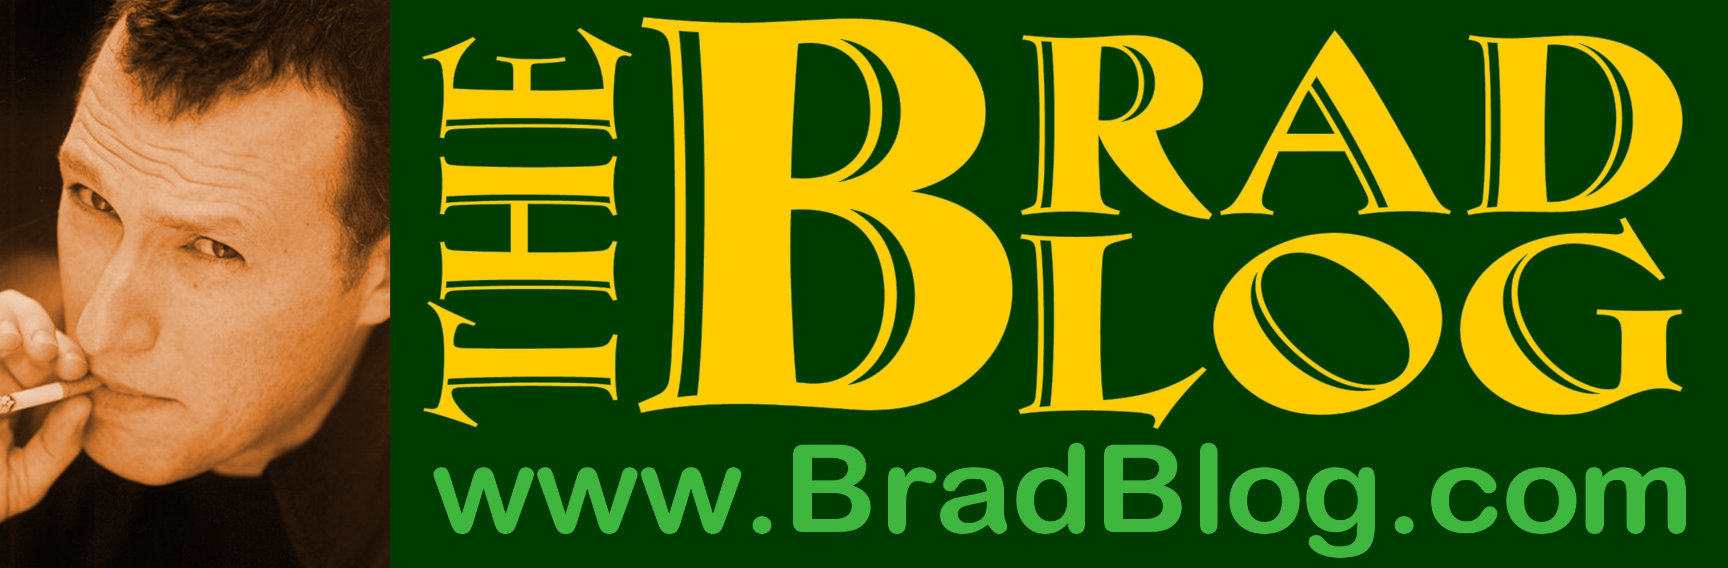

Where? – www.bradblog.com
When? July 8, 2005 3pm PDT (6pm EST) until
July 11, 2005 6pm PDT (9pm EST)

What’s Planned?

Silent Auctions Gifts for Donation Contests &More

Live Guest Bloggers: Larisa Alexandrovna John Amato David Cobb

Clint Curtis Bob Fitrakis Robert Koehler Winter Patriot

Other Guest Bloggers: Bernie Ellis Chris Floyd Josh Mitteldorf

Additional information about the event can be found at: http://www.bradblog.com/archives/00001457.htm
Stop by to find out more about the event or just to read up on current events. Isn’t it time we learned the truth?

*An event entirely conceived, planned and produced by “6 or 7” Bradbloggers.

